Applicant Information Pack
Class Teacher

‘Every Individual is in a great school’

Letter from the Headteacher

Dear Applicant,

Thank you for the interest you have shown in our school. Much Wenlock Primary School is situated in the picturesque town of Much Wenlock. It is a wonderful community school, with the children drawn mostly from the local area and town centre.

We are a popular school with around 180 children on roll, in 7 classes. We also have an onsite Nursery which caters for children from 2 years upwards. The school prides itself on having a close-knit and nurturing feeling.

Much Wenlock Primary School is a successful school where pupils achieve well. We pride ourselves on creativity and a love for all the subjects in our creative curriculum, embracing special talents and celebrating all successes. We take great pride in our school. Our Senior Leadership Team is constantly in pursuit of excellence whilst putting the children’s and staff’s best interests at the heart of all decision making. We are a very dedicated whole-school team who set high expectations for our pupils, and have the well-being, enjoyment and progress of both children and staff at the centre of our positive ethos.

We are committed to enriching the curriculum for our children through a wide range of after school- clubs, trips, performances, House competitions, community work and collaboration with other schools. It is important to us to offer as many opportunities as possible to the children and regularly draw on the local links and town centre history that sits on our door step. We have a very inclusive approach. Our Learning Mentor supports children, parents and teachers within the school.

At Much Wenlock Primary School, our community is very important to all of us: this includes children, staff, and families past and present. This means that our pupils are well behaved, enjoy their learning and consider school to be an important part of their life, along with their teachers - of whom they value very much.

Our staff are our greatest asset: we are committed to continued professional development for all our staff as we aim to make our community as successful as possible. We foster open, professional and respectful relationships across the school and staff well-being and happiness is paramount.

This recruitment pack contains details about our school, the 3-18 Multi Academy Trust, and the commitment to our staff and students. Please explore our website and read the additional materials included in this pack to find out more.

If you decide that you have the energy, enthusiasm and experience to enhance our culture and make a difference, then we look forward to your application. If you would like to arrange a visit or an informal discussion then please contact our School Office via email info@wps.318education.co.uk

Yours faithfully,

Carl Litchfield,
Headteacher

Nurture Inspire Believe Achieve

About our School
About Us
At Much Wenlock Primary School, we pride ourselves on our welcoming learning environment, where a friendly atmosphere is combined with an air of purpose. We are fortunate in the high quality of all our staff. Parents and governors are involved and supportive, and the children themselves help to drive school improvement through our School Council and House Group system.
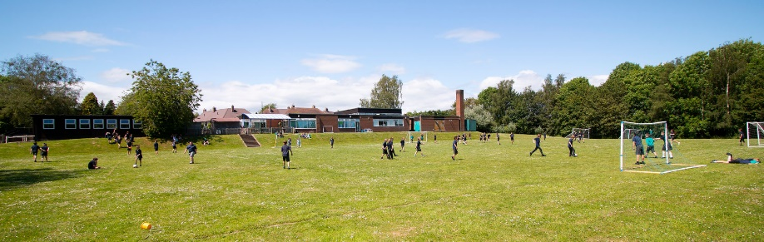
Everyone works together to maximise the educational opportunities and personal well-being of each and every child. Children make good progress as they grow through the school and achieve well. We are proud to teach children with a wide range of skills, and our motto of ‘Nurture, Inspire, Believe, Achieve’ is lived out every day. Our school sits at the heart of a wonderful community and we pride ourselves on being responsive to the families we serve. The school staff strive to make Much Wenlock Primary school and Nursery a happy and successful learning environment for all children.
Facilities
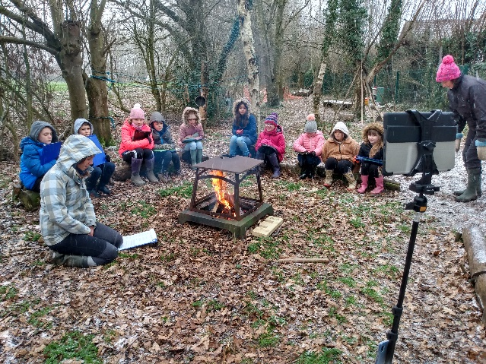
Situated on the edge of the historic and popular town of Much Wenlock, just south of the Ironbridge Gorge and fourteen miles south-east of Shrewsbury, we are within easy reach of an enormous range of learning environments; rural, urban, historic and modern. Our own extensive grounds provide excellent facilities. They include a large sports field and two hard playgrounds with a range of markings for team games and other activities. There are further large grassed areas and a range of natural habitats, including woodland and a living willow den and a “secret garden” which has been developed for Forest School activities.

Ethos and Values
At Much Wenlock Primary School we value each and every child and celebrate their individuality. We are committed to nurturing and inspiring children to be happy, confident learners. We achieve this by working together to create meaningful and enjoyable experiences. In this way we strive to instil a lifelong love of learning and achieving.
This vision and our motto ‘Nurture, Inspire, Believe, Achieve’ underpin our core whole school values of: Honesty, Empathy, Responsibility, Respect, Tolerance and Resilience.

About our Trust

The 3-18 Education Trust is currently made up of eight schools and derives its name from the age range of the pupils and students who attend those schools. We have an inclusive ethos, defined by age and we recognise that education is a continuous process, secured through consistent values and a strong transition (through the key stages).

Our Vision:
To ensure every individual is in a great school.

Our Mission:
To celebrate the diverse nature, culture and identity of our individual schools, whilst enjoying the benefit of the team, so that each school is reciprocal in their support for one another and achieves together.

Our Values:

- Accomplished: to provide high quality education and training for all
- Resilient: to be solution focused and able to intelligently manage challenges
- Compassionate: to show care and understanding towards others

Not only do we pursue the important dimension of achieving the best results for each student regardless of their starting point, but we also believe strongly that education is about developing well-rounded individuals who are ready, willing and able to make their contribution to society.

Please take a look at our Trust website https://www.3-18education.co.uk/ for more details on what we offer. For information about each of our schools, please read on or click on the below links.
Bowbrook Primary – The 3-18 Education Trust
Coleham Primary – The 3-18 Education Trust
The Priory School – The 3-18 Education Trust
St Martins 3-16 School – The 3-18 Education Trust
Thomas Adams School – The 3-18 Education Trust
Williams Brookes School – The 3-18 Education Trust
Much Wenlock Primary – The 3-18 Education Trust
Bridgnorth Endowed School – The 3-18 Education Trust
Hodnet Primary School – The 3-18 Education Trust

The 3-18 Trust: What We Offer
The 3-18 Education Trust is a multi-academy trust with students aged from 3-18 and which works collaboratively to provide interesting and exciting opportunities for staff to share ideas, resources and expertise, for the benefit of the students. Our Schools serve their communities of small villages and the larger towns throughout Shropshire.

The 3-18 Education Trust has a philosophy that ensures that each school within the Trust has its own Head and Local Governing Body and can maintain its own ethos and independence whilst enjoying support and additional capacity where required from the Trust. The Trust is absolutely committed to ensuring that each of its constituent schools retains its unique identity, whilst the combined experience and expertise available provide a dynamic synergy. Our school within our Trust is an excellent place to develop your career.

In addition to a comprehensive induction and a commitment to your ongoing training and career progression, we also offer:
- A competitive salary
- Access to the Trust’s Employee Assistance Programme, which includes 24 hour access for you and your family members to legal, financial, health, parenting and life advice
- 1:1 Counselling Service
- Discount Scheme for high street retailers, mobile phone providers, holidays, electrical goods, supermarkets, restaurants, cinema, etc.
- Cycle to Work Scheme
- Childcare Voucher Scheme or Tax-Free Childcare Scheme
- Access to freshly made hot meals or deli-style food on site
- Teachers Pensions (23.68% employer contributions)
- Local Government Pension Scheme (17.9% employer contribution)
- Generous Sickness Payment Scheme
- Eye Testing Scheme
- Flexible Working Policy
- Special Leave Policy
- Member of the Valued Worker Scheme (accredited by our recognised unions)
- A Disability Confident Committed Employer
- Continuous Professional Development (CPD)
- Collaborative working culture and professional development opportunities across our Trust schools
We are also currently exploring:
- Electric/Hybrid Car Lease Scheme
- Healthcare Scheme
Hours & Working Weeks
Work-life balance is important in our Trust. Having the ability to organise your working hours in a way that suits you, whilst not compromising your hours and standard of work, alongside meeting the requirements of the post and the needs of the Trust can help to achieve this work-life balance. It may be to avoid a busy commute or to allow time to work around childcare or caring for dependents.

Job Description: Class Teacher

Title of Post | Class Teacher
Salary/TLR/ Allowance | MPS 1 - 3
Post Status | Fixed Term Contract 0.6 FTE (3 days)
Accountable To | Headteacher

Main Purpose
Under the direction of the Headteacher, the Class Teacher must play a major role in the school community and:
- Fulfil the professional responsibilities of a teacher, as set out in the School Teachers’ Pay and Conditions Document;
- Meet the expectations set out in the Teachers’ Standards.
The Teacher is subject to the provisions of the School Teachers’ Pay and Conditions Document.
Teacher Duties & Responsibilities
Plan and teach well-structured lessons to assigned classes, following the school’s plans, curriculum and schemes of work;
Assess, monitor, record and report on the learning needs, progress and achievements of assigned pupils, making accurate and productive use of assessment;
Adapt teaching to respond to the strengths and needs of pupils;
Set high expectations which inspire, motivate and challenge pupils;
Promote good progress and outcomes by pupils;
Demonstrate good subject and curriculum knowledge;
Participate in arrangements for preparing pupils for external tests;
Create a stimulating and safe learning environment;
Inform parents of children’s progress through formal and informal parent consultations and an annual report;
Take part in CPD as appropriate to the role;
Undertake duties and tasks under the reasonable direction of the Headteacher;
Lead a core curriculum area.
Subject Co-ordination
In order to carry out this responsibility the post holder should:
- Become sufficiently expert to advise staff;
- Scrutinise subject work throughout school on a half termly basis (at least);
- Monitor the teaching and learning in the subject throughout school and feedback to teachers;
- Work with the SLT to analyse whole school data;
- Develop and implement subject policy, plans, targets and practices;
- Provide those who teach the subject with support, where appropriate;
- Keep abreast of new developments through reading and attending appropriate courses and research best practice within other schools;
- Action plan for the subject area, developing priorities for improvement and driving this forward;
- Plan and organise enrichment linked to your subject, curriculum days, visitors, trips, clubs etc;
- Ensure the subject is a priority within a broad and balanced curriculum and promoted to parents via PR; Be responsible for a curriculum area of display.
Whole-school organisation, strategy and development
Contribute to the development, implementation and evaluation of the school’s policies, practices and procedures, so as to support the school’s values and vision;
Make a positive contribution to the wider life and ethos of the school;
Be willing to lead extra-curricular activity and attend some school events;
Work with others on curriculum and pupil development to secure coordinated outcomes.
Health, safety and discipline
Promote the safety, safeguarding and wellbeing of pupils;
Maintain good order and discipline among pupils, managing behaviour effectively to ensure a good and safe learning environment.
Professional development
Take part in the school’s appraisal procedures;
Take part in further training and development in order to improve own teaching;
Where appropriate, take part in the appraisal and professional development of others.
Help keep knowledge and understanding relevant and up-to-date by reflecting on your own practice, liaising with school leaders, and identifying relevant professional development to improve personal effectiveness
Take opportunities to build the appropriate skills, qualifications, and/or experience needed for the role, with support from the school
Communication
Communicate effectively with pupils, parents and carers;
Collaborate and work with colleagues and other relevant professionals within and beyond the school;
Develop effective professional relationships with colleagues.

Personal and professional conduct
Uphold public trust in the profession and maintain high standards of ethics and behaviour, within and outside school.
Safeguarding
Take responsibility for understanding and following school safeguarding policies and procedures.
Other Responsibilities
Comply with and assist with the development of policies and procedures relating to child protection, health, safety and security, confidentiality and data protection, reporting all concerns to an appropriate person.
Be aware of and comply with all school policies and procedures
Be aware of and support difference and ensure equal opportunities for all
Contribute to the overall ethos and aims of the School and Trust
Appreciate and support the role of other professionals
Attend and participate in relevant meetings, training and learning activities as required
The postholder may be required to carry out any other duties that are commensurate with the post. Whilst every effort is made to explain the main duties and responsibilities of the post each individual task undertaken may not be identified.
This job description is subject to review, in negotiation with the post holder at any time. However, an annual review of this job description and allocation of responsibilities will take place as part of agreed performance management arrangements.

Person Specification
 | Essential | Desirable
Qualifications | - Qualified teacher status  - Bachelor’s Degree
Work or relevant experience | - Excellence in classroom teaching | - Evidence of leading a core subject
Skills and Abilities (relevant to post) | - Sufficiently fluent in spoken English to ensure effective performance in the role  - Ability to interpret and analyse class data to track and monitor student performance.  - The ability to build positive relationships with colleagues, students and parents  - Knowledge of guidance and requirements around safeguarding children  - Knowledge of effective behaviour management strategies  - Ability to create a calm, well-organised and attractive learning environment | - Experience and willingness to lead extra-curricular activities
Personal Qualities | - A commitment to getting the best outcomes for all pupils and promoting the ethos and values of the school  - Ability to work under pressure and prioritise effectively  - Excellent personal skills and the ability to become a valuable part of a real team  - A genuine belief and alignment with Much Wenlock’s values and ethos
Special Conditions | - Willingness to undertake an enhanced Disclosure and Barring Service (DBS) check

Application & Appointment Process
An application form is available to download from the school website which can be found here.

Please complete and return your application form as soon as possible, clearly noting all the
experience, skills and personal qualities that you can offer which are relevant to this post.

Please send completed applications to Shelagh Enticknap, School Business Manager at shelagh.enticknap@wps.318education.co.uk

Interviews will be offered to those applicants who best demonstrate how skills, abilities and experience match the person specification, taking into consideration the job description.

Closing date for applications: 12.00 Noon, Tuesday 7th May 2024

Interviews will take place: Friday 17th May 2024

If you wish to arrange an informal discussion to find out more about this post, please contact the school office: info@wps.318education.co.uk

Please note:
- It is essential that all elements of the application form are completed in full.
- We do not accept CV’s in support of an application.
- Appointments will be subject to clearance in respect of medical fitness, satisfactory references, right to work in the UK and criminal disclosure.
- This post is exempt from the Rehabilitation of Offenders act 1974 and as such the applicant who is appointed to this post will be subject to an Enhanced Disclosure before the appointment is confirmed. This check will include details of cautions, reprimands or warnings, as well as convictions and non-conviction information. Once appointed, the successful applicant may also be required to apply for an Enhanced Disclosure at intervals during the course of their employment whilst in this post.

If invited for interview, you are required to bring evidence of your qualifications and appropriate documents to initiate the DBS application process should you be the successful candidate

The 3-18 Education Trust is committed to safeguarding and promoting the welfare of children and young people.
This post is exempt from the Rehabilitation of Offenders act 1974 and as such shortlisted candidates must complete a declaration including details of any cautions, reprimands or warnings, as well as convictions and non-conviction information. It is an offence to apply for this role if you are barred from engaging in regulated activity relevant to children.
Any successful candidates offer of employment will be subject to clearance in respect of medical fitness, satisfactory references, right to work in the UK and an Enhanced Disclosure and Barring Service Check before their appointment is confirmed. Once appointed, the successful applicant may also be required to apply for an Enhanced Disclosure at intervals during the course of their employment.
In line with Keeping Children Safe in Education (KCSiE), online checks will be carried out on the successful applicant.

